

Sri Lanka Institute of Information Technology

**SKY GYM ONLINE MANAGEMENT SYSTEM**

Project Proposal

Information Technology Project (IT2080)

2019

ITP-2019-MLB-G9-08

Submitted by:

1. IT18050868 – Z.M.M.Akaam
2. IT18152074 – Sangeeth Raj.A
3. IT18144772– Krishnamoorthy.N
4. IT18108132– Edirisinghe E.N.V
5. IT18118650– Jayasooriya D.C.
6. IT18044928– J.L Thilini Randika
7. IT18128932– Devduni.R.M.B
8. IT18118414 – Imalsha Kavindi K.G.

Submitted to:

Ms. Uthpala Samarakoon

…………………………..

(Supervisor’s signature)

21 July 2019

**Table of Contents Page No.**

1. Introduction
   1. Client Background………………………………………………………….. 3
   2. Problems Faced by Client and Corresponding Solutions…………………… 3-6
2. Benefits of the system…………………………………………………………....……. 7
3. System Overview Diagram…………………………………………………………….. 8
4. System Functionalities
   1. Customer Management…………………………………………………............ 9 - 10
   2. Employee Management………………………………………………………... 10 - 11
   3. Schedule Management………………………………………………………….. 11 -12
   4. Payment Management…………………………………………………………... 13
   5. Diet Plan Management…………………………………………………….......... 14
   6. Online Store…………..………………………………………………................ 14 -15
   7. Finance Management ………………………………………………................... 15
   8. Inventory Management ………………………………………………………… 15
   9. Report Management…………………………………………………................. 16
5. Tools and Technologies……………………………………………………….................. 17
6. Gantt Chart………………………………………………………………………………… 18
7. Task Distribution ………………………………………………………….......................19-20
8. **INTRODUCTION**

**1.1 Client Background**

Sky Gym fitness is located in Kandy which was established in the year 2015. They currently have 1643 registered members at their gym, out of which roughly 30% are active members. Sky Gym has a variety of workout schedules sub-divided in few categories based on different requirements for each schedule they have a trainer in charge. All the trainers who are employed at Sky Gym are part time workers and currently they have 18 trainers working with them.

Sky Gym is equipped with highly sophisticated equipment and they hold an inventory count of 723 which includes weights, benches, dumbbells, kettlebells, gym balls and fitness equipment and etc.

**1.2 PROBLEMS & SOLUTIONS**

1. **Handling customers and trainers**

**Problem**

Handling the employees and customers are the most challenging task Sky Gym is currently facing. They do not have proper records of their customer fee payments and trainer salary payments. Due to this problem they have had instances where they had misunderstandings between their customers and trainer (especially with trainers).

In addition to this they also do not have proper records of their customers also they have misplaced some of the past records.

**Solution**

Employee management will help to store all trainer and customer information and retrieve them whenever needed. As a result they will be able to manage the gym efficiently and more effectively. This helps them to improve their management and have better control.

1. **Marketing the Business**

**Problem**

Currently the client is following the traditional way of marketing the gym such as posters and leaflets.

**Solution**

Online gym store makes it easier for both our client and their customers. Our client does not need to spend time designing poster to cover all their facilities and amenities as they have the ability to show up all their facilities using this web application. In the customers point of view they too will have a better idea about the gym if they browse this system.

In addition to that it is easier for potential customer to navigate to the web page and check for the services offered by Sky Gym rather than visiting the gym to get the information.

1. **Diet Plans for Customers**

**Problem**

Customers currently do not follower a proper diet plan since the gym does not provide any proper plans. However, majority of the customers had requested for a healthy food plan and the trainers at the gym used to randomly suggest diet plans which the customers did not like.

**Solution**

Food diet management of our system suggests diet plans for the members at the gym depending on their Body Mass Index (BMI). However, customers are yet free to choose other dietary plans based on their requirement if they do not prefer the suggested plans.

1. **Schedules**

**Problem**

Currently the customers at Sky Gym do not have a way to track their workout progress. Besides this the members, especially new members, do not have knowledge about their workout schedules.

**Solution**

Schedule management in our system helps the customer to know his/her schedule. Moreover, they will be suggested with suitable schedules based on their gender and type of workout customer needs.

1. **Inventory and stock management**

**Problem**

Purchase of store goods and payment made by customers are manually recorded, they are not maintained properly, client request a solution to check the overall monthly stock. Moreover, they have had instances where their equipment such as dumbbells were stolen/misplaced. So they did not realize it for a long time and were too late when the realized it.

**Solution**

Online store manages the availability of goods and inventory management handling the payment and keep record of each transaction and update inventory management when goods are out of stock.

1. **Bill payment**

**Problem**

The bills of the gym are handled manually and Sky Gym does not have a proper knowledge about the bill expenses they incur. This problem prevents them from identifying the realistic profit/loss generated by the gym over a period of time.

**Solution**

Financial management system helps to keep records of bill payments and online transactions and produce monthly income and expenditure of the gym.

1. **BENEFITS OF THE SYSTEM**

Our Online Gym Store System has many benefits for Sky Gym. In addition to the solutions given to the problems the gym has key benefits when considering the gym as a whole. The most significant benefit is that the administrator has less work and the gym can be maintained and controlled more efficiently.

Moreover, the system maintain a proper records of all aspects of the organization and also enables to generate reports. This will help them to review their performance, identify instances where they can improve and finally produce better results in terms of standards and profits.

1. **SYSTEM OVERVIEW**

**SKY GYM Online Management System**

**Member**

**Trainer**

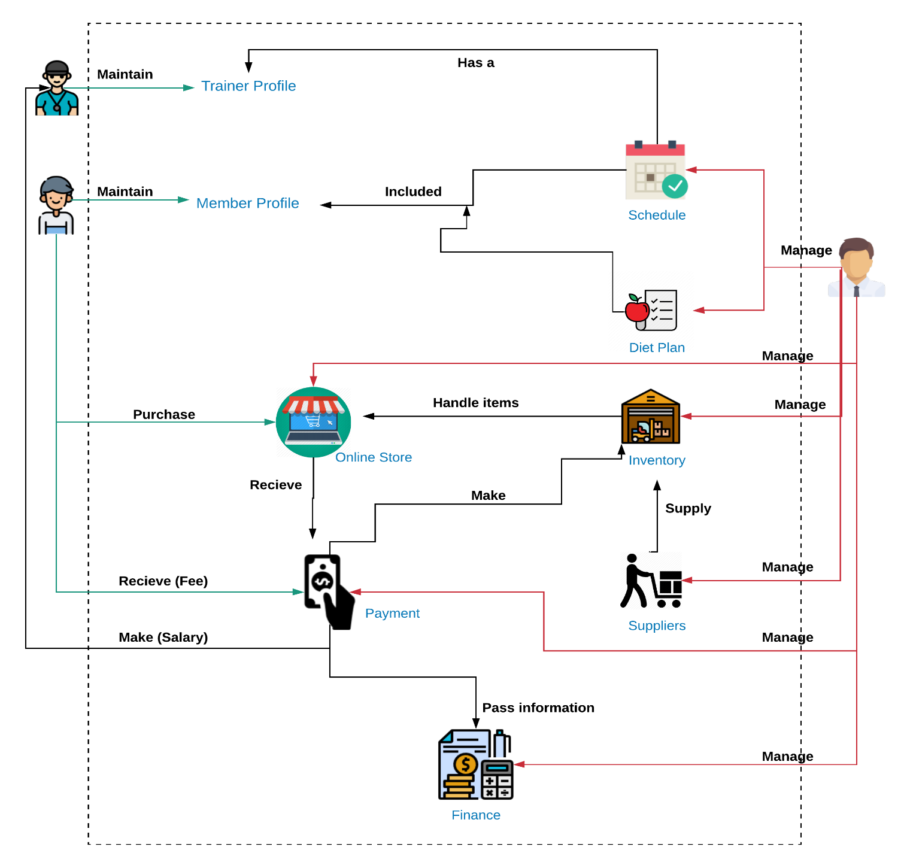

**Trainer**

**Member**

**Adminnraor**

**System Database**



1. **FUNCTIONALITIES**

The system consists of 9 major functions. The functionalities are divided into 3 user perspectives which are - trainer’s side, administrator’s side and the customer’s side - for better understanding of each functionality and how it may apply in practical scenarios.

* 1. **Customer Management System**

**Customer Side**

The customer can directly register by signing up to the system entering the required details. But to activate their account they have to make the payment to the gym only then the administrator will activate his/her profile.

Once the customer logins into his/her account they will be able to view their current schedule and their workout progress of that particular schedule. They will be able to mark their daily attendance. Whenever, they mark their attendance the workout progress of the current schedule will increase. Once the customer is done with a particular schedule the system will suggest a new schedule or else the customer will be able to continue with the same schedule.

Moreover, a registered member will be able to update their personal information such as their age, weight, password and profile picture.

**Administrator Side**

The administrator has the authority to add, update and delete customers. In case if a member does not want to attend the gym again his record can be deleted by the administrator. The search function helps the administrator to search for a customer by their name or Membership ID.

Moreover, the administrator can generate monthly reports of members at the gym and a member report based on the gender.

* 1. **Employee Management**

**Administrator Side**

Only the administrator can add, update and delete trainers and administrators of the system. When trainer profiles are created they will be given a default password (chosen by the admin) which they can later change as per their preference.

Administrator will mark the attendance of all the employees (administrators and trainers).

In addition to that, the administrator will also be able to search a trainer using the trainer ID or the schedule that particular trainer is handling.

The administrator shall calculate the salary of a trainer which includes his/her overtime earnings (salary + overtime). Employees are assigned to the section which they are specialized in when they are added to the system. The bonus, allowance and overtime rate differ according to the specialization of the trainer. So that administrator can add, update, delete and view specialization category list.

Administrator can search for an employee using the Employee ID.

Finally, the administrator can to generate salary reports individually and an overall report of all employees but only the overall report will be stored in the system and the individual employee reports will be only for reference purposes.

**Trainer's Side**

In the trainer’s side he/she can update limited information such as personal information, profile image, biography, password etc. The trainer will also be able to view the trainees that he/she is in currently responsible for.

* 1. **Schedule Management**

**Customer Side**

Schedule management as a function will allow the customer to select a schedule depending on their personal preference and requirement. The levels of schedules will be divided as follows:

1. Beginner
2. Intermediate
3. Advance
4. Professional

When selected a schedule the member will have to select on which category (mentioned below) they are selecting and once they select a category they will be suggested with schedules of all the 4 levels mentioned above. In addition to this the suggested schedules will differ based on the gender of the member.

Once a member completes a schedule they will be able to switch to a new schedule. The user will be able to switch his category or continue with the same category. However, the member has the freedom to choose other schedules regardless of what he/she is suggested with.

The schedules will categorized into 4 different type as follows:

1. Weight loss
2. Muscle building
3. Cardio
4. Calisthenics

These schedules will be stored in a PDF file.

**Administrator Side**

The schedules available for the members can be updated or deleted and new schedules can be added by the admin. A schedule can be deleted only if there are no customers using that particular schedule. Besides this the system allows the administrator to search for a specific schedule with the name of the schedule. Finally the administrator has the ability to generate reports of schedules based on the schedules and a gender based report.

Besides this the administrator has to assign a trainer to a particular schedule based on the area that they are specialized in (weight loss, muscle building, cardio or calisthenics).

* 1. **Payment Management**

**Administrator Side**

When a member registered to the gym they will have to select a payment scheme. Following are 3 payment methods currently available at Sky Gym:

1. Monthly Basis
2. Six Months
3. Annual Basis

The administrator has the ability add new schemes and update or remove the existing schemes. Administrator also has to keep track of the payments of the members. In case a member has a due administrator can notify him/her about the due. If a member has not made their payments for more than 3 months then they access to the system will be block until they pay the due.

The administrator should be able to search the customer’s payments history/details by typing the customer name also should be able to enter the receipt number and search which customer did that payment.

Finally the administrator can generate reports of payments made. The overall monthly report of all payments will be stored and individual payment reports (such as individual customer payments) will be generate only for reference purposes.

**Customer Side**

The customer can view the payments due.

* 1. **Diet Plan Management**

**Administration Side**

The administrator can add, update and delete diet plans for the members to use. These diet plans will be stored in a PDF file. Diet plans will be categorized as following:

1. Weight Loss
2. Muscle Building
3. Athlete
4. Cardio / Calisthenics

The administrator can also search for a particular diet plan using the name of the diet plan or the diet plan Identification Number (ID).

Finally the administrator will be able to generate an overall report of all the diet plans.

**Customer Side**

The customer will be able to pick a diet plan based on his/her motive and preference. In the meantime the system will suggest a few diet plans to the member based on their Body Mass Index (BMI). However, the member is free to choose other diet plans regardless of what he/she is suggested with.

* 1. **Online Store**

**Customer Side**

The store is available only for the registered members of the gym. Members can view and add the products they need to the cart and if they wish to purchase they can checkout and a bill will be displayed. There after they can make the payments at the gym and collect their items. The customer can search the products he/she needs by entering the name of the product.

**Administrator Side**

The store inventory will be handled by administrator. The store will have products such as supplements, gym accessories, small gym equipment etc. The payments made to the online store will be handled and recorded in this part of the system.

* 1. **Finance Management**

**Administration Side**

Finance management functionality allows the administrator to calculate the total income and expenses of the gym. The income of the gym includes the income earned through the gym membership and the gym store.

Whereas expenses of the gym are the bills of the gym, store item purchases, and the trainer salaries. Therefore, using these figures the administrator can calculate the profit of the gym and generate monthly and annual reports. In addition to this our client will be able to search for a particular income or expenditure by using the date or name.

* 1. **Inventory Management**

**Administrator Side**

Inventory management helps to keep track of all the inventory of the gym. This refers to all the equipment and accessories available at the gym. The administrator can add, update and delete inventory in the system. In addition to that after an estimated period of time the system will show up for an equipment maintenance request through which the administrator will be able to request for maintenance from their suppliers.

Moreover, the equipment of the gym can be searched using the equipment code or the equipment ID.

* 1. **Report Management**

**Administrator Side**

This functionality will allow the administrator to manage the reports obtained through other functionalities. The administrator can add, delete and organize reports that are in the system.

**TECHNOLOGIES & TOOLS**

* JavaScript & JavaScript Frameworks
* C# - Asp.Net
* MySQL

**GANTT CHART**

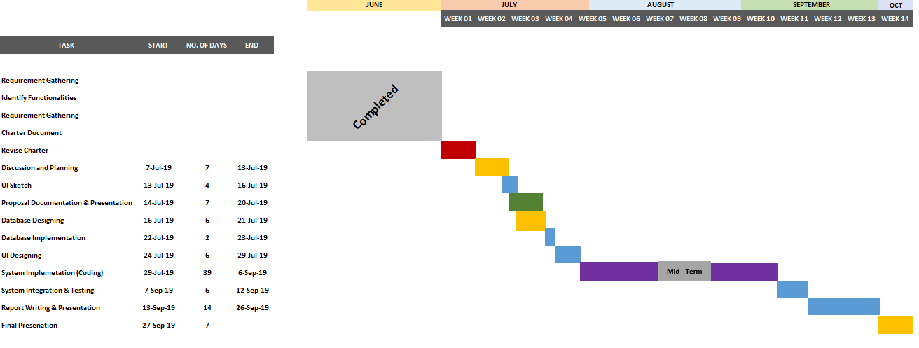

**TASK DISTRIBUTION**

|  |  |
| --- | --- |
| Name with Initials | Brief Description of the Function |
| Z.M.M. Akaam | **Inventory Management (Gym)**  **Report Management** |
| Sangeeth Raj .A | **Online Store** |
| Krishnamoorthy.N | **Schedule Management** |
| Edirisinghe E.N.V | **Employee Management** |
| Jayasooriya D.C. | **Diet Plan Management** |
| J.L Thilini Randika | **Customer Management** |
| Devduni.R.M.B | **Payment Management** |
| Imalsha Kavindi K.G. | **Finance Management** |